PRACTICAL 04

Q1. Write a shell script to check whether the entered number is prime or not.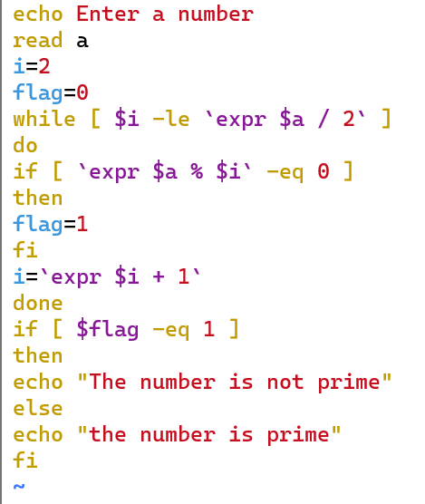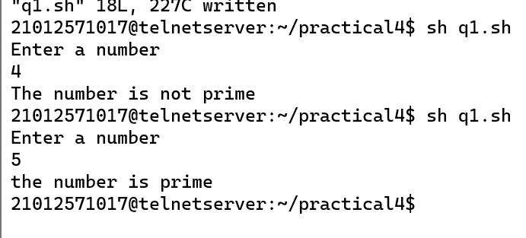

Q2. Write a shell script to calculate HRA of employees depending upon their basic.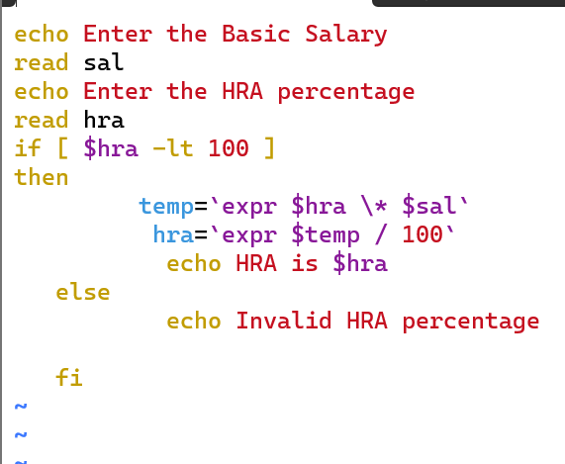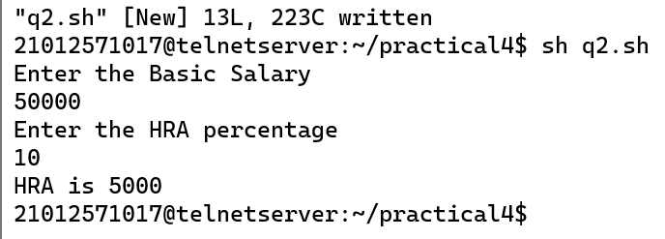

Q3. Write a shell script that greets the user by saying Good Morning, Good Afternoon, and Good Evening according to the system time.

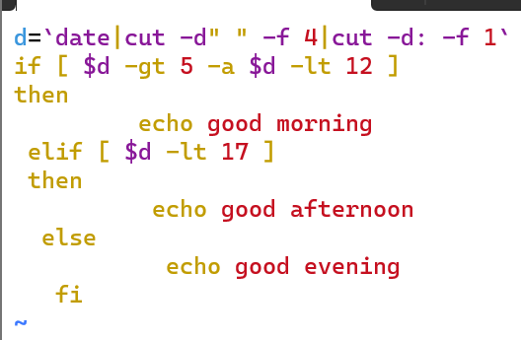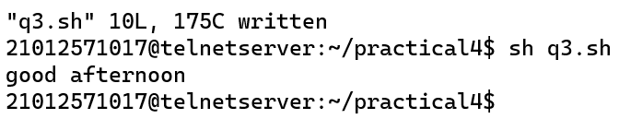

Q4. Write a shell script, which takes a filename as command line argument, asks the user if he wants to revoke the read, write permissions for the group and others for that particular file. If the answer is “y” then it should do so or else it should abort the operation.

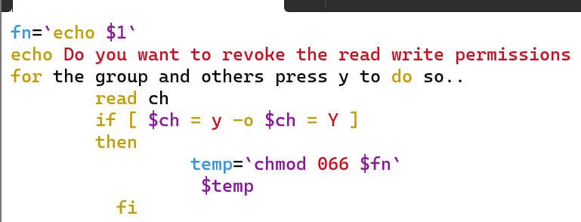

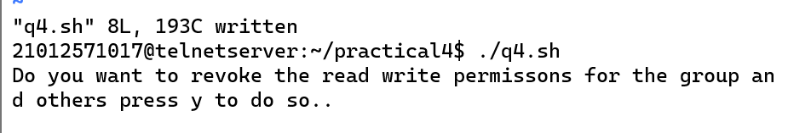

Q5. Write a shell script that asks the capital of Gujarat and repeats the question until the user gives correct answer.

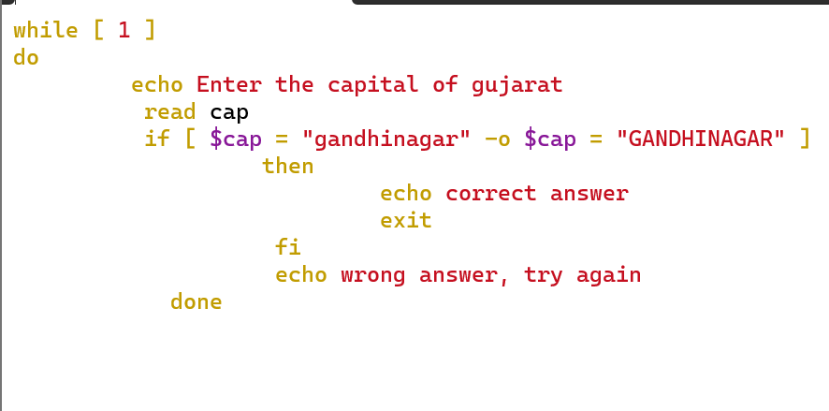

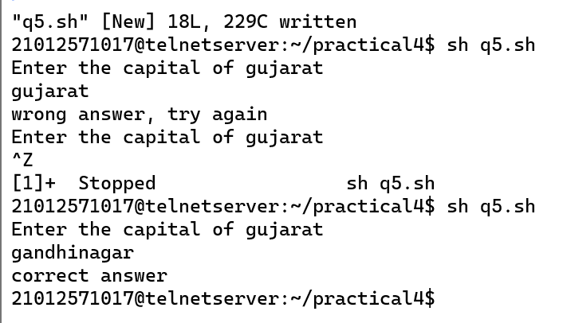

Q6. Write a shell script to display desired line from a file

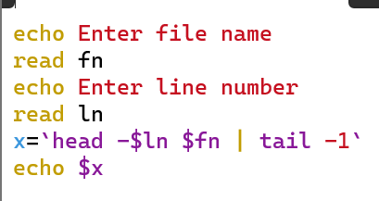

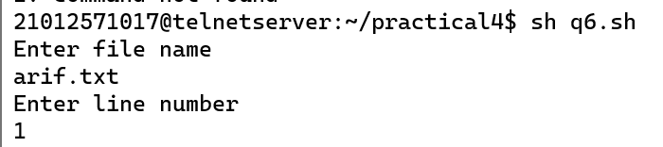

Q7. Write a shell script to count number of newline characters in a file.

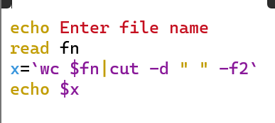

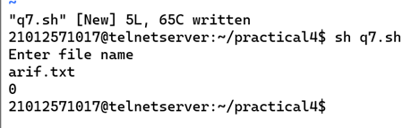

Q8. Write a shell script to count number of spaces in a file.

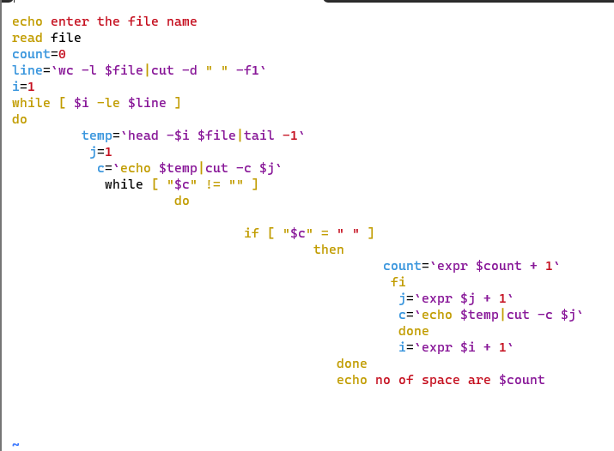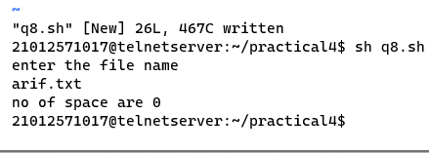

Q9. Write a Shell script, which counts the number of words in a file, without taking into consideration the blank space, tab spaces and the newline characters using WC.

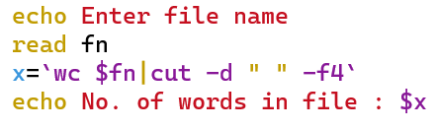

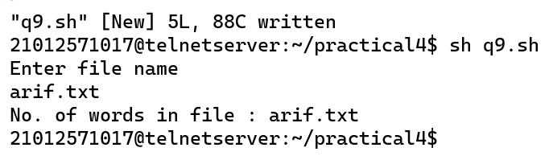

Q10. Write a Shell script, which counts the number of words in a file, without taking into consideration the blank space, tab spaces and the newline characters without using WC.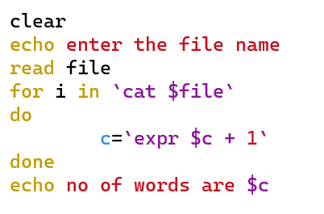

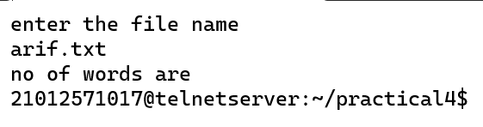

Q11. Write a Shell script, which counts the number of characters in a file, without taking into consideration the blank space, tab spaces and the newline characters using WC.

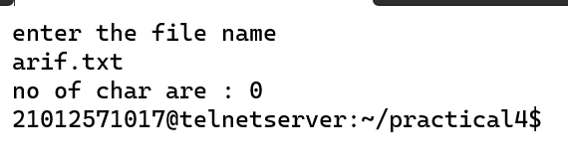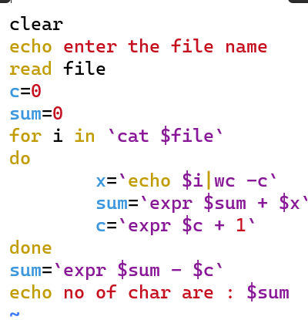

Q12. Write a Shell script, which counts the number of characters in a file, without taking into consideration the blank space, tab spaces and the newline characters without usin